Library concerned: Cornwall Health Library
Name of case study: Integrating journal clubs into the AHP Future Leaders Programme
Date of interview: 4 June 2020

Interviewee | Name: Sue ApThomas  Job Title: Knowledge Services Manager  Trust/Employing body: Royal Cornwall Hospitals NHS Trust  Email: s.apthomas@nhs.net  Tel: 01872 256444
Interviewee | Please note: you should only provide interviewee details here if consent  to share on the national blog has been obtained
Summary of problem or reason for enquiry | Carrie Biddle is the Trust’s Therapy Clinical Governance and Quality Lead, and is responsible for organising the AHP Future Leaders Programme at the Royal Cornwall Hospital, designed to develop home-grown leadership expertise. An essential part of this programme is developing leadership in the culture of evidence based practice (EBP), which includes using the library resources and skills of librarians.
Brief description of the information found / service provided | Carrie believes that teaching delegates to understand and interpret research is essential to EBP, and asked the Library and Knowledge Services to host a journal club session teaching critical appraisal for each cohort of the programme. The library teaches the skills needed to unpick the research using tools that are easy to adopt such as the CASP evaluation framework.  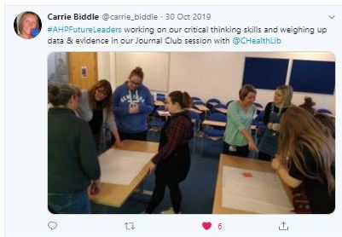

Summary of outcome and impact | Increase in the culture of evidence based practice by AHPs shown by the adoption of journal clubs and literature search requests.
Immediate Impact  (including quotes) | As a result of the library journal club teaching, delegates have gained skills and confidence to enable them to organise journal clubs in their own clinical areas. Carrie commented “It’s having skilled facilitation that makes the difference”  As a result, the learning process from the journal clubs has become integrated into the delegates’ own clinical teams. For example, the journal club format has been adopted as part of the inservice training programmes for several AHP areas, including Speech and Language Therapy, Physiotherapy and Dietetics.  We have also noticed a significant increase in literature searches requested by AHPs since the programme has been running. In 2018/19 the library had 19 search requests from AHPs. The following year we had 37 - an increase of 100%
Probable future Impact  (including quotes) | This increase in evidence use via journal clubs and literature searches is indicative of the widespread adoption of an evidence culture amongst AHPs via the Future Leaders Programme. It is probable that this increased awareness amongst leaders will result in improvements in patient care, service delivery and increased innovation.  The Library and Knowledge Service supports the programme’s aim to create leaders who act as change agents with the power to make a positive difference.

